CHAPTER 13
Biodiversity and Conservation
• Biodiversity and Conservation

Ch 13 | BIODIVERSITY AND CONSERVATION - Chapter Opener

Chapter contents (as printed on the opener page): 13.1 Biodiversity; 13.2 Biodiversity Conservation.
If an alien from a distant galaxy were to visit our planet Earth, the first thing that would amaze and baffle him would most probably be the enormous diversity of life that he would encounter. Even for humans, the rich variety of living organisms with which they share this planet never ceases to astonish and fascinate us.
Group | Number of species (NCERT opener)
Ants | more than 20,000 species
Beetles | 3,00,000 species
Fishes | 28,000 species
Orchids | nearly 20,000 species

Ecologists and evolutionary biologists have been struck by six questions, which frame the whole chapter:
• Why are there so many species?
• Did such great diversity exist throughout earth's history?
• How did this diversification come about?
• How and why is this diversity important to the biosphere?
• Would it function any differently if the diversity was much less?
• How do humans benefit from the diversity of life?
13.1 | BIODIVERSITY

In our biosphere immense diversity (or heterogeneity) exists not only at the species level but at all levels of biological organisation, ranging from macromolecules within cells to biomes.
• Biodiversity is the term popularised by the sociobiologist Edward Wilson to describe the combined diversity at all the levels of biological organisation.
Diversity exists at many levels; the most important of them are three - genetic diversity, species diversity and ecological diversity.
Level of diversity | What it means (NCERT) | NCERT example
(i) Genetic diversity | A single species might show high diversity at the genetic level over its distributional range. | The genetic variation shown by the medicinal plant Rauwolfia vomitoria growing in different Himalayan ranges might be in terms of the potency and concentration of the active chemical (reserpine) that the plant produces. India has more than 50,000 genetically different strains of rice and 1,000 varieties of mango.
(ii) Species diversity | Diversity at the species level. | The Western Ghats have a greater amphibian species diversity than the Eastern Ghats.
(iii) Ecological diversity | Diversity at the ecosystem level. | India, with its deserts, rain forests, mangroves, coral reefs, wetlands, estuaries and alpine meadows, has a greater ecosystem diversity than a Scandinavian country like Norway.

It has taken millions of years of evolution to accumulate this rich diversity in nature, but we could lose all that wealth in less than two centuries if the present rates of species losses continue. Biodiversity and its conservation are now vital environmental issues of international concern, as more and more people around the world begin to realise the critical importance of biodiversity for our survival and well-being on this planet.
13.1.1 | How Many Species are there on Earth and How Many in India?

Since there are published records of all the species discovered and named, we know how many species in all have been recorded so far, but it is not easy to answer the question of how many species there are on earth.
• IUCN - the International Union for Conservation of Nature and Natural Resources.
• According to the IUCN (2004), the total number of plant and animal species described so far is slightly more than 1.5 million.
• But we have no clear idea of how many species are yet to be discovered and described. Estimates vary widely and many of them are only educated guesses.
• For many taxonomic groups, species inventories are more complete in temperate than in tropical countries.
How biologists arrive at a gross estimate of the global species total:
1 | Recognise that an overwhelmingly large proportion of the species waiting to be discovered are in the tropics.
2 | Make a statistical comparison of the temperate-tropical species richness of an exhaustively studied group of insects.
3 | Extrapolate this ratio to other groups of animals and plants.
4 | Arrive at a gross estimate of the total number of species on earth.

Estimate of global species diversity | Value
Some extreme estimates | 20 to 50 million species
A more conservative and scientifically sound estimate made by Robert May | about 7 million species
Species recorded so far (IUCN 2004) | slightly more than 1.5 million
Species still waiting to be discovered and named (stated in the NCERT chapter summary) | nearly 6 million species on earth

• More than 70 per cent of all the species recorded are animals, while plants (including algae, fungi, bryophytes, gymnosperms and angiosperms) comprise no more than 22 per cent of the total.
• Among animals, insects are the most species-rich taxonomic group, making up more than 70 per cent of the total. That means, out of every 10 animals on this planet, 7 are insects.
• NCERT stops here to ask, and does not answer: "Again, how do we explain this enormous diversification of insects?" - the same puzzle exercise 9 puts as how animals achieved their greater diversification.
[NOTE] Two different NCERT statements about Fungi, and both are examinable. The body says the number of fungi species in the world is more than the combined total of the species of fishes, amphibians, reptiles and mammals (four classes, birds not included). The chapter summary makes the broader claim that the group Fungi has more species than all the vertebrate species combined. Learn both forms - the broader summary sentence does not replace the body's exact four-class list.

[NOTE] Number mismatch NEET can quote either way. The body says animals are more than 70 per cent of recorded species and plants 22 per cent. NCERT exercise 9 states the same comparison as plants 22 per cent versus animals 72 per cent. The exact 72 per cent figure appears only in the exercise, so accept both the "more than 70 per cent" and the "72 per cent" form.

In Figure 13.1, biodiversity is depicted showing species number of major taxa.
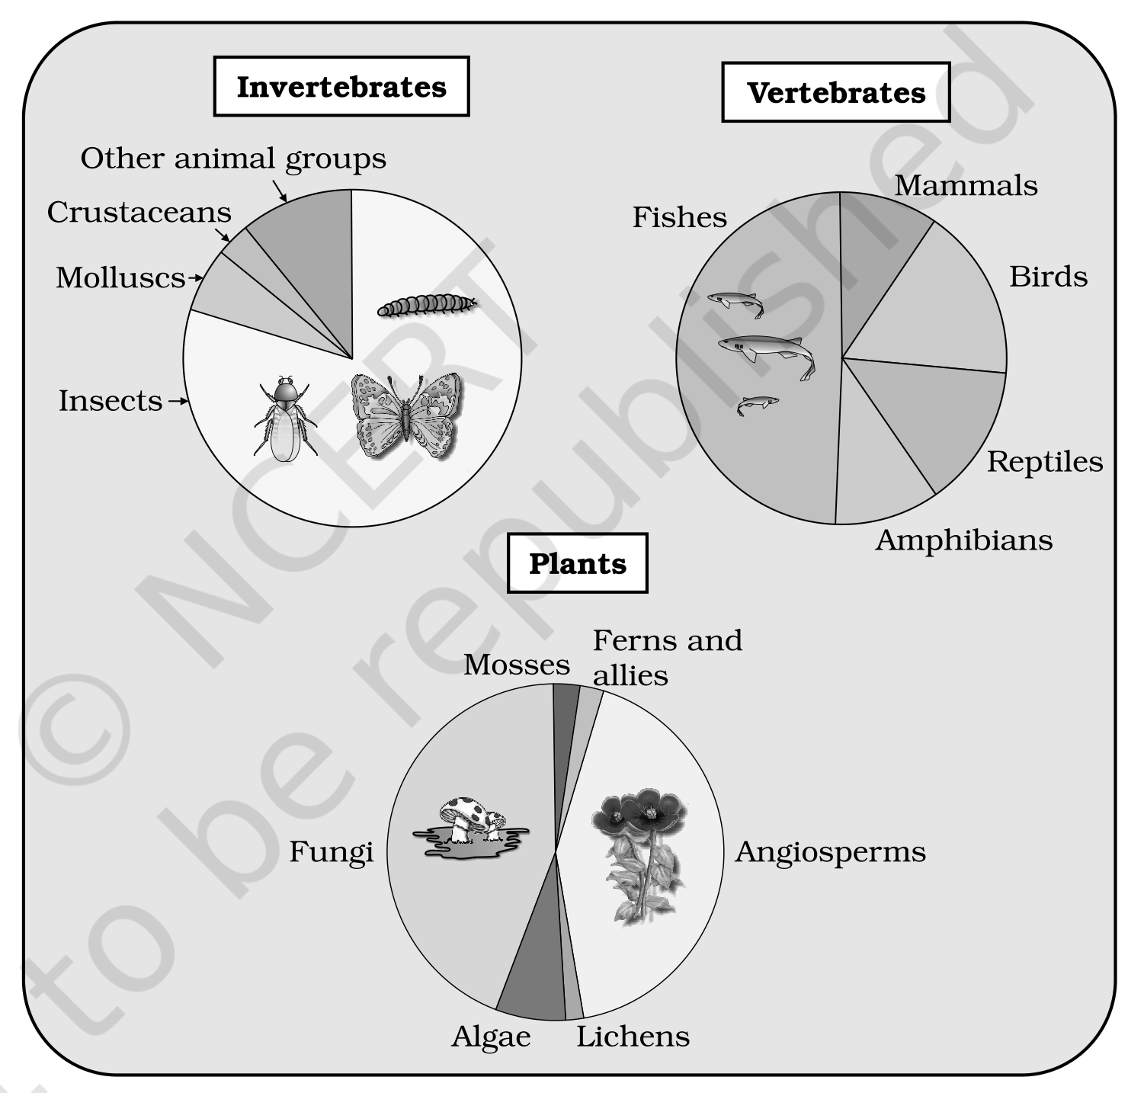
Fig. 13.1 - Representing global biodiversity: proportionate number of species of major taxa of plants, invertebrates and vertebrates. The three panels are labelled Invertebrates, Vertebrates and Plants; NCERT prints no numeric percentages inside the figure, so the proportions are given in the running text above.
What each panel of Figure 13.1 names (the figure carries these group labels only, with no numbers printed on it):
Panel | Groups labelled in that panel of Figure 13.1
Invertebrates | Insects (by far the largest wedge), Crustaceans, Molluscs and Other animal groups.
Vertebrates | Fishes, Birds, Reptiles, Mammals and Amphibians.
Plants | Angiosperms, Fungi, Algae, Mosses, Ferns and allies and Lichens.

• It should be noted that these estimates do not give any figures for prokaryotes.
• Biologists are not sure how many prokaryotic species there might be. Conventional taxonomic methods are not suitable for identifying microbial species, and many species are simply not culturable under laboratory conditions.
• If we accept biochemical or molecular criteria for delineating species for this group, then their diversity alone might run into millions.
India's share of global biodiversity:
Item | Figure (NCERT)
India's share of the world's land area | only 2.4 per cent
India's share of the global species diversity | an impressive 8.1 per cent - which is what makes our country one of the 12 mega diversity countries of the world
Species recorded from India | nearly 45,000 species of plants and twice as many of animals
Proportion of all species recorded so far, if we accept May's global estimate | only 22 per cent of the total
Applying that proportion to India's figures, species yet to be discovered and described in India | probably more than 1,00,000 plant species and more than 3,00,000 animal species

NCERT then asks two questions of its own: "How many living species are actually there waiting to be discovered and named?" and "Would we ever be able to complete the inventory of the biological wealth of our country?"
Consider the immense trained manpower (taxonomists) and the time required to complete the job. The situation appears more hopeless when we realise that a large fraction of these species faces the threat of becoming extinct even before we discover them - nature's biological library is burning even before we catalogued the titles of all the books stocked there.
13.1.2 | Patterns of Biodiversity

13.1.2 (i) | Latitudinal gradients

The diversity of plants and animals is not uniform throughout the world but shows a rather uneven distribution. For many group of animals or plants there are interesting patterns in diversity, the most well-known being the latitudinal gradient in diversity.
• In general, species diversity decreases as we move away from the equator towards the poles.
• With very few exceptions, tropics (latitudinal range of 23.5 degrees N to 23.5 degrees S) harbour more species than temperate or polar areas.
Place | Latitude | Species richness (NCERT figures)
Colombia | near the equator | nearly 1,400 species of birds
New York | 41 degrees N | 105 species of birds
Greenland | 71 degrees N | only 56 species of birds
India | much of its land area in the tropical latitudes | more than 1,200 species of birds
Equador (tropical) versus the Midwest of the USA (temperate) | tropical versus temperate | A forest in a tropical region like Equador has up to 10 times as many species of vascular plants as a forest of equal area in a temperate region like the Midwest of the USA.

The largely tropical Amazonian rain forest in South America has the greatest biodiversity on earth. Its recorded inventory:
Group | Species in the Amazonian rain forest
Plants | more than 40,000
Fishes | 3,000
Birds | 1,300
Mammals | 427
Amphibians | 427
Reptiles | 378
Invertebrates | more than 1,25,000

• Scientists estimate that in these rain forests there might be at least two million insect species waiting to be discovered and named.
What is so special about tropics that might account for their greater biological diversity? Ecologists and evolutionary biologists have proposed various hypotheses; some important ones are:
Hypothesis | Reasoning (NCERT)
(a) More evolutionary time | Speciation is generally a function of time. Unlike temperate regions subjected to frequent glaciations in the past, tropical latitudes have remained relatively undisturbed for millions of years and thus had a long evolutionary time for species diversification.
(b) Constant, predictable environment | Tropical environments, unlike temperate ones, are less seasonal, relatively more constant and predictable. Such constant environments promote niche specialisation and lead to a greater species diversity.
(c) More solar energy | There is more solar energy available in the tropics, which contributes to higher productivity; this in turn might contribute indirectly to greater diversity.

13.1.2 (ii) | Species-Area relationships

During his pioneering and extensive explorations in the wilderness of South American jungles, the great German naturalist and geographer Alexander von Humboldt observed that within a region species richness increased with increasing explored area, but only up to a limit.
• For a wide variety of taxa - angiosperm plants, birds, bats, freshwater fishes - the relation between species richness and area turns out to be a rectangular hyperbola, of the form S = CA^{Z}.
• On a logarithmic scale the relationship is a straight line described by the equation log S = log C + Z log A (the same equation is printed on the figure as Log S = log C + Z log A, plotted on a log-log scale).
• In this equation: S = Species richness; A = Area; Z = slope of the line (regression coefficient); C = Y-intercept.
Scale of the analysis | Value of Z (slope) | NCERT evidence
Within a region - small areas | 0.1 to 0.2, regardless of the taxonomic group or the region | Whether it is the plants in Britain, birds in California or molluscs in New York state, the slopes of the regression line are amazingly similar.
Very large areas - entire continents | much steeper: 0.6 to 1.2 | For frugivorous (fruit-eating) birds and mammals in the tropical forests of different continents, the slope is found to be 1.15.

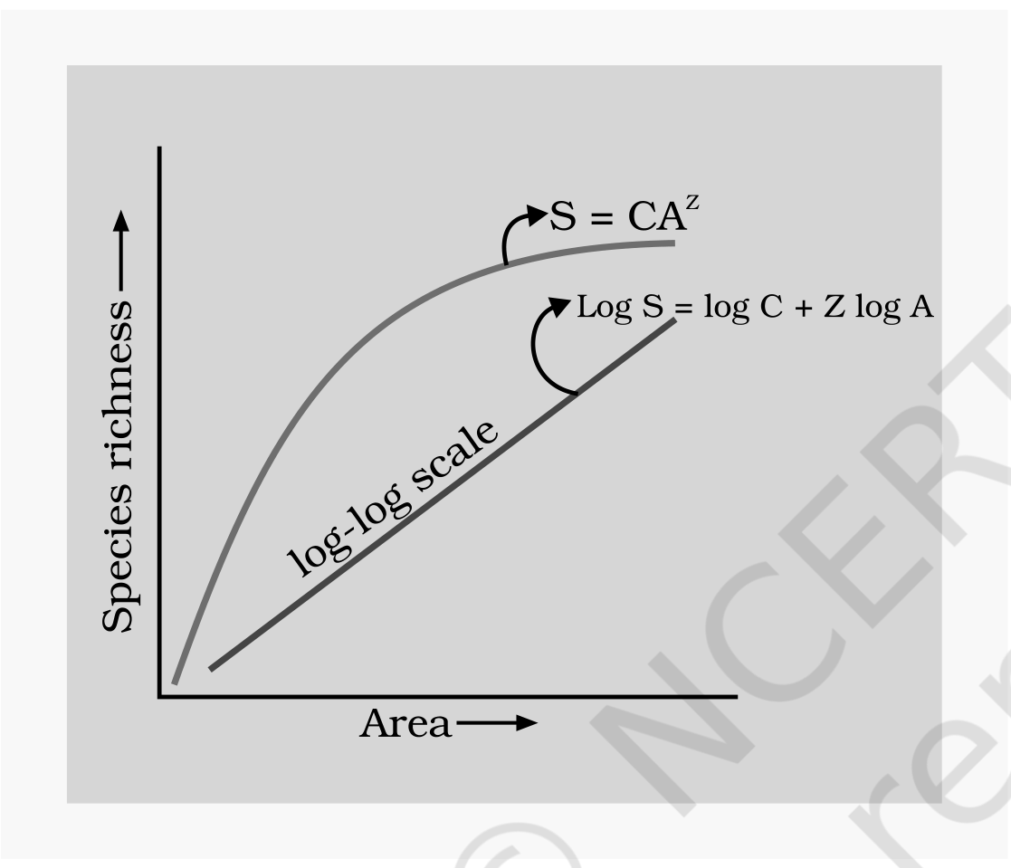
Fig. 13.2 - Showing species area relationship. Note that on log scale the relationship becomes linear. Colour-loss note: the original NCERT figure told its two plots apart by colour, so read them here by tone - the mid-grey curve is the rectangular hyperbola S = CA^{Z} of Species richness against Area on an arithmetic scale, and the near-black straight line is the same relationship on a log-log scale, labelled Log S = log C + Z log A.
[NOTE] NCERT asks, and leaves unanswered in the body: "What do steeper slopes mean in this context?" - and exercise 4 asks for the significance of the slope of regression in a species-area relationship. A steeper slope (a larger Z) means species richness rises faster for every unit increase in area. That is why whole continents accumulate species far more steeply (Z of 0.6 to 1.2, and 1.15 for frugivorous birds and mammals) than habitat patches within one region, where Z stays a shallow 0.1 to 0.2 whatever the taxon or region.

13.1.3 | The importance of Species Diversity to the Ecosystem

Does the number of species in a community really matter to the functioning of the ecosystem? This is a question for which ecologists have not been able to give a definitive answer.
• For many decades, ecologists believed that communities with more species, generally, tend to be more stable than those with less species.
• NCERT then asks: "What exactly is stability for a biological community?"
• A stable community should not show too much variation in productivity from year to year; it must be either resistant or resilient to occasional disturbances (natural or man-made); and it must also be resistant to invasions by alien species.
We don't know how these attributes are linked to species richness in a community, but David Tilman's long-term ecosystem experiments using outdoor plots provide some tentative answers:
• Plots with more species showed less year-to-year variation in total biomass.
• Increased diversity contributed to higher productivity.
• The chapter summary states this in exam-shaped form: it is believed that communities with high diversity tend to be less variable, more productive and more resistant to biological invasions.
• Rich biodiversity is not only essential for ecosystem health but imperative for the very survival of the human race on this planet.
NCERT poses three questions here:
• Does it really matter to us if a few species become extinct?
• Would Western Ghats ecosystems be less functional if one of its tree frog species is lost forever?
• How is our quality of life affected if, say, instead of 20,000 we have only 15,000 species of ants on earth?
There are no direct answers to such naive questions, but a proper perspective comes through an analogy - the 'rivet popper hypothesis' used by Stanford ecologist Paul Ehrlich:
1 | In an airplane (ecosystem) all parts are joined together using thousands of rivets (species).
2 | If every passenger travelling in it starts popping a rivet to take home (causing a species to become extinct), it may not affect flight safety (proper functioning of the ecosystem) initially.
3 | But as more and more rivets are removed, the plane becomes dangerously weak over a period of time.
4 | Furthermore, which rivet is removed may also be critical: loss of rivets on the wings (key species that drive major ecosystem functions) is obviously a more serious threat to flight safety than loss of a few rivets on the seats or windows inside the plane.

13.1.4 | Loss of Biodiversity

While it is doubtful if any new species are being added (through speciation) into the earth's treasury of species, there is no doubt about their continuing losses. The biological wealth of our planet has been declining rapidly and the accusing finger is clearly pointing to human activities.
Recorded loss | NCERT figure
Extinction following the colonisation of tropical Pacific Islands by humans | said to have led to the extinction of more than 2,000 species of native birds
Extinctions documented by the IUCN Red List (2004) in the last 500 years | 784 species, including 338 vertebrates, 359 invertebrates and 87 plants (the chapter summary rounds this to nearly 700 species extinct in recent times)
Some examples of recent extinctions | the dodo (Mauritius), quagga (Africa), thylacine (Australia), Steller's Sea Cow (Russia) and three subspecies (Bali, Javan, Caspian) of tiger
Disappearance in the last twenty years alone | 27 species
Species currently facing the threat of extinction world-wide | more than 15,500 species (the chapter summary adds that more than 650 of these are from India)

• Careful analysis of records shows that extinctions across taxa are not random; some groups like amphibians appear to be more vulnerable to extinction.
Presently, the groups facing the threat of extinction in the world are:
Group | Share of all species in that group facing the threat of extinction
Birds | 12 per cent
Mammals | 23 per cent
Amphibians | 32 per cent
Gymnosperms | 31 per cent

• From a study of the history of life on earth through fossil records, we learn that large-scale loss of species like the one we are currently witnessing have also happened earlier, even before humans appeared on the scene.
• During the long period (more than 3 billion years) since the origin and diversification of life on earth there were five episodes of mass extinction of species. The chapter summary dates the origin of life more precisely: life originated on earth nearly 3.8 billion years ago, since when there had been enormous diversification of life forms.
• How is the 'Sixth Extinction' presently in progress different from the previous episodes? The difference is in the rates. The current species extinction rates are estimated to be 100 to 1,000 times faster than in the pre-human times, and our activities are responsible for the faster rates.
• Ecologists warn that if the present trends continue, nearly half of all the species on earth might be wiped out within the next 100 years.
In general, loss of biodiversity in a region may lead to:
• (a) decline in plant production;
• (b) lowered resistance to environmental perturbations such as drought;
• (c) increased variability in certain ecosystem processes such as plant productivity, water use, and pest and disease cycles.
13.1.4 | Causes of biodiversity losses - 'The Evil Quartet'

The accelerated rates of species extinctions that the world is facing now are largely due to human activities. There are four major causes - 'The Evil Quartet' is the sobriquet used to describe them.
(i) Habitat loss and fragmentation:
• This is the most important cause driving animals and plants to extinction.
• The most dramatic examples of habitat loss come from tropical rain forests. Once covering more than 14 per cent of the earth's land surface, these rain forests now cover no more than 6 per cent. By the time you finish reading this chapter, 1000 more hectares of rain forest would have been lost.
• The Amazon rain forest - so huge that it is called the 'lungs of the planet' - harbouring probably millions of species, is being cut and cleared for cultivating soya beans or for conversion to grasslands for raising beef cattle.
• Besides total loss, the degradation of many habitats by pollution also threatens the survival of many species.
• When large habitats are broken up into small fragments due to various human activities, mammals and birds requiring large territories and certain animals with migratory habits are badly affected, leading to population declines.
(ii) Over-exploitation:
• Humans have always depended on nature for food and shelter, but when 'need' turns to 'greed', it leads to over-exploitation of natural resources.
• Many species extinctions in the last 500 years - Steller's sea cow, passenger pigeon - were due to overexploitation by humans.
• Presently many marine fish populations around the world are over harvested, endangering the continued existence of some commercially important species.
(iii) Alien species invasions:
• When alien species are introduced unintentionally or deliberately for whatever purpose, some of them turn invasive, and cause decline or extinction of indigenous species.
Alien species | What it did (NCERT)
Nile perch introduced into Lake Victoria in east Africa | led eventually to the extinction of an ecologically unique assemblage of more than 200 species of cichlid fish in the lake
Carrot grass (Parthenium), Lantana and water hyacinth (Eicchornia) | invasive weed species
Recent illegal introduction of the African catfish Clarias gariepinus for aquaculture purposes | posing a threat to the indigenous catfishes in our rivers

(iv) Co-extinctions:
• Co-extinction: when a species becomes extinct, the plant and animal species associated with it in an obligatory way also become extinct.
• When a host fish species becomes extinct, its unique assemblage of parasites also meets the same fate.
• Another example is the case of a coevolved plant-pollinator mutualism, where extinction of one invariably leads to the extinction of the other.
[MEMORY AID - not in NCERT] For NCERT exercise 10 ("can you think of a situation where we deliberately want to make a species extinct, and how would you justify it?") the chapter itself supplies no content at all, so this reasoning is outside NCERT and is not examinable as NCERT text. The defensible answer is a disease-causing organism that exists only to harm - the smallpox virus (already eradicated), the polio virus, or the Guinea worm. Justification: eradicating such a parasite ends enormous human suffering, and these organisms occupy no ecosystem role that other species depend on obligatorily.

13.2 | BIODIVERSITY CONSERVATION

13.2.1 | Why Should We Conserve Biodiversity?

There are many reasons, some obvious and others not so obvious, but all equally important. They can be grouped into three categories: narrowly utilitarian, broadly utilitarian, and ethical.
13.2.1 | Narrowly utilitarian arguments

• The narrowly utilitarian arguments for conserving biodiversity are obvious: humans derive countless direct economic benefits from nature - food (cereals, pulses, fruits), firewood, fibre, construction material, industrial products (tannins, lubricants, dyes, resins, perfumes) and products of medicinal importance.
• More than 25 per cent of the drugs currently sold in the market worldwide are derived from plants, and 25,000 species of plants contribute to the traditional medicines used by native peoples around the world.
• Nobody knows how many more medicinally useful plants there are in tropical rain forests waiting to be explored.
• Bioprospecting - exploring molecular, genetic and species-level diversity for products of economic importance. With increasing resources put into bioprospecting, nations endowed with rich biodiversity can expect to reap enormous benefits.
13.2.1 | Broadly utilitarian arguments

• The broadly utilitarian argument says that biodiversity plays a major role in many ecosystem services that nature provides.
• The fast-dwindling Amazon forest is estimated to produce, through photosynthesis, 20 per cent of the total oxygen in the earth's atmosphere. Can we put an economic value on this service by nature? You can get some idea by finding out how much your neighborhood hospital spends on a cylinder of oxygen.
• Pollination - without which plants cannot give us fruits or seeds - is another service ecosystems provide through pollinators: bees, bumblebees, birds and bats. What will be the costs of accomplishing pollination without help from natural pollinators?
• There are other intangible benefits we derive from nature - the aesthetic pleasures of walking through thick woods, watching spring flowers in full bloom or waking up to a bulbul's song in the morning. Can we put a price tag on such things?
[NOTE] Summary-sourced list, and the answer to exercise 8. The chapter summary (not the body) states that besides the direct benefits - food, fibre, firewood, pharmaceuticals and so on - there are many indirect benefits we receive through ecosystem services such as pollination, pest control, climate moderation and flood control. Exercise 8 additionally asks how the biotic components deliver control of floods and soil erosion; soil erosion is named nowhere in this chapter, so that part is necessary inference, not NCERT text: vegetation cover and root systems bind the soil and slow surface run-off, so rain soaks in instead of sheeting off, which both checks erosion and moderates flooding.

13.2.1 | The ethical argument

The ethical argument for conserving biodiversity relates to what we owe to millions of plant, animal and microbe species with whom we share this planet. Philosophically or spiritually, we need to realise that every species has an intrinsic value, even if it may not be of current or any economic value to us. We have a moral duty to care for their well-being and to pass on our biological legacy in good order to future generations.
13.2.2 | How do we conserve Biodiversity?

When we conserve and protect the whole ecosystem, its biodiversity at all levels is protected - we save the entire forest to save the tiger. This approach is called in situ (on site) conservation.
• Endangered or threatened - organisms facing a very high risk of extinction in the wild in the near future.
However, when there are situations where an animal or plant is endangered or threatened and needs urgent measures to save it from extinction, ex situ (off site) conservation is the desirable approach.
13.2.2 | In situ conservation

• Faced with the conflict between development and conservation, many nations find it unrealistic and economically not feasible to conserve all their biological wealth.
• Invariably, the number of species waiting to be saved from extinction far exceeds the conservation resources available. On a global basis, this problem has been addressed by eminent conservationists.
• Biodiversity hotspots - regions identified for maximum protection because they have very high levels of species richness and a high degree of endemism, that is, species confined to that region and not found anywhere else.
Biodiversity hotspots - the numbers | NCERT figure
Hotspots identified | initially 25, but subsequently nine more have been added, bringing the total number of biodiversity hotspots in the world to 34
What else these hotspots are | they are also regions of accelerated habitat loss
Hotspots covering India | three - Western Ghats and Sri Lanka, Indo-Burma and Himalaya - cover our country's exceptionally high biodiversity regions
Land area they cover | all the biodiversity hotspots put together cover less than 2 per cent of the earth's land area, yet the number of species they collectively harbour is extremely high
Value of protecting them | strict protection of these hotspots could reduce the ongoing mass extinctions by almost 30 per cent

• In India, ecologically unique and biodiversity-rich regions are legally protected as biosphere reserves, national parks and sanctuaries. India now has 14 biosphere reserves, 90 national parks and 448 wildlife sanctuaries.
[NOTE] Two figures for the same item. The body gives 448 wildlife sanctuaries; the chapter summary writes the same in-situ effort as more than 450 wildlife sanctuaries (alongside the 14 biosphere reserves, 90 national parks and many sacred groves). Take 448 as the exact body figure and recognise the summary's more than 450 form if NEET quotes it.

• India has also a history of religious and cultural traditions that emphasised protection of nature. In many cultures, tracts of forest were set aside, and all the trees and wildlife within were venerated and given total protection.
• Such sacred groves are found in the Khasi and Jaintia Hills in Meghalaya, the Aravalli Hills of Rajasthan, the Western Ghat regions of Karnataka and Maharashtra and the Sarguja, Chanda and Bastar areas of Madhya Pradesh.
• In Meghalaya, the sacred groves are the last refuges for a large number of rare and threatened plants.
13.2.2 | Ex situ Conservation

• In this approach, threatened animals and plants are taken out from their natural habitat and placed in special setting where they can be protected and given special care.
• Zoological parks, botanical gardens and wildlife safari parks serve this purpose.
• There are many animals that have become extinct in the wild but continue to be maintained in zoological parks.
• In recent years ex situ conservation has advanced beyond keeping threatened species in enclosures:
Modern ex situ technique | What it preserves (NCERT)
Cryopreservation techniques | gametes of threatened species can now be preserved in viable and fertile condition for long periods
In vitro fertilisation | eggs can be fertilised in vitro
Tissue culture methods | plants can be propagated using tissue culture
Seed banks | seeds of different genetic strains of commercially important plants can be kept for long periods

• Biodiversity knows no political boundaries and its conservation is therefore a collective responsibility of all nations.
1 | 1992, Rio de Janeiro - the historic Convention on Biological Diversity ('The Earth Summit') called upon all nations to take appropriate measures for conservation of biodiversity and sustainable utilisation of its benefits.
2 | 2002, Johannesburg, South Africa - in a follow-up, the World Summit on Sustainable Development saw 190 countries pledge their commitment to achieve by 2010 a significant reduction in the current rate of biodiversity loss at global, regional and local levels.

Recap | QUICK RECAP

• Life originated nearly 3.8 billion years ago; since then there has been enormous diversification of life forms. Biodiversity (term popularised by Edward Wilson) is the sum total of diversity at all levels of biological organisation; conservation targets the genetic, species and ecosystem levels.
• More than 1.5 million species recorded (IUCN 2004); nearly 6 million may still await discovery, against Robert May's global estimate of about 7 million and extreme estimates of 20 to 50 million. More than 70 per cent of named species are animals, of which more than 70 per cent are insects; plants are no more than 22 per cent. Fungi outnumber fishes + amphibians + reptiles + mammals combined (summary: more than all vertebrates combined). Prokaryotes are not counted in these estimates.
• India: 2.4 per cent of the land area, 8.1 per cent of global species diversity, about 45,000 plant species and twice as many animal species - one of the 12 mega diversity countries.
• Patterns: species diversity is highest in the tropics and decreases towards the poles - explained by more evolutionary time, a relatively constant, less seasonal environment promoting niche specialisation, and more solar energy giving higher productivity. Species richness also rises with area as a rectangular hyperbola, S = CA^{Z}, linear on a log-log scale as log S = log C + Z log A; Z is 0.1 to 0.2 within a region and 0.6 to 1.2 across continents (1.15 for frugivorous birds and mammals).
• Communities with high diversity tend to be less variable, more productive and more resistant to biological invasions (Tilman's plots; Ehrlich's rivet popper analogy warns that losing key species is worst of all).
• Losses: five past mass extinctions; the Sixth Extinction differs in rate - 100 to 1,000 times pre-human rates, with nearly half of all species possibly gone within 100 years. 784 species extinct in 500 years (summary: nearly 700), 27 in the last twenty years, more than 15,500 threatened (more than 650 in India); 12 per cent of birds, 23 per cent of mammals, 32 per cent of amphibians, 31 per cent of gymnosperms.
• Causes - 'The Evil Quartet': habitat loss and fragmentation (the most important; rain forests down from more than 14 per cent to no more than 6 per cent of land surface), over-exploitation (Steller's sea cow, passenger pigeon), alien species invasions (Nile perch in Lake Victoria killing more than 200 cichlid species; Parthenium, Lantana, Eicchornia; Clarias gariepinus) and co-extinctions (host-parasite, plant-pollinator mutualism).
• Why conserve: narrowly utilitarian (food, firewood, fibre, industrial products, medicines - more than 25 per cent of drugs plant-derived, 25,000 plant species in traditional medicine, plus bioprospecting), broadly utilitarian (ecosystem services - the Amazon's 20 per cent of atmospheric oxygen, pollination, pest control, climate moderation, flood control, and aesthetic benefits) and ethical (every species has intrinsic value; pass the legacy on in good order).
• How to conserve: in situ - 34 biodiversity hotspots (less than 2 per cent of land area; strict protection could cut mass extinctions by almost 30 per cent), of which three cover India; 14 biosphere reserves, 90 national parks, 448 wildlife sanctuaries (summary: more than 450) and sacred groves. Ex situ - zoological parks, botanical gardens, safari parks, cryopreservation of gametes, in vitro fertilisation, tissue culture and seed banks. Globally: Rio de Janeiro 1992 (Earth Summit) and Johannesburg 2002 (190 countries, target year 2010).
Appendix | TERMS USED IN THE EXERCISES

All 10 NCERT exercises were scanned. Six (Q1, Q2, Q3, Q5, Q6, Q7) are fully answerable from the chapter body. Four assume something the chapter never supplies - each is closed here.
Exercise | What it assumes | Where it is answered
Q4 | The significance of the slope (Z) of the regression in a species-area relationship. The body only asks "What do steeper slopes mean in this context?" and never answers it. | A steeper slope means species richness rises faster per unit area. Whole continents give Z of 0.6 to 1.2 (1.15 for frugivorous birds and mammals), against a shallow Z of 0.1 to 0.2 for areas within one region. See the NOTE at the end of 13.1.2 (ii).
Q8 | Control of floods and soil erosion as ecosystem services delivered by the biotic components. Flood control is named only in the chapter summary; soil erosion is named nowhere in the chapter. | Vegetation cover and root systems bind the soil and slow surface run-off, so water soaks in rather than sheeting away - checking erosion and moderating floods. Marked in 13.2.1 as summary-sourced plus necessary inference, not body text.
Q9 | The figure animals 72 per cent against plants 22 per cent. The body says animals are more than 70 per cent; the exact 72 per cent appears only in the exercise. | Both forms are valid - see the NOTE in 13.1.1. Plant species diversity (22 per cent) is much less than that of animals (72 per cent in the exercise's wording).
Q10 | A situation where we deliberately want to make a species extinct, and its justification. The body offers no content at all on deliberate extinction. | Answered in the MEMORY AID box at the end of 13.1.4, and explicitly marked not in NCERT: disease-causing organisms such as the smallpox virus, polio virus and Guinea worm.

